

**<<QUIZ PRACTICING SYSTEM>>**

**Software Requirement Specification-Group 4**

**Duong Trung Huy (Leader)**

**Phan Nguyen Duc Hieu**

**Nguyen Nam Phuong**

**Vu Nguyen Tran Duy**

**Luong Viet Thang**

– Hanoi, September 2021 –

**Table of Contents**

***I. Overview***

***1. Introduction***

***2. System Functions***

***3. Common Requirements***

***II. Functional Requirements***

## *1.Commone Feature*

***a. User Login***

***b. User Register***

***c. Reset Password***

***d. User Authorization***

***e. User Profile***

***f. Change Password***

## *2. Public Feature*

***a. Home Page***

***b. Blogs list***

***c. Blog Details***

***d. Subject List***

***e. Subject Details***

***f. Subject Register***

## 3. Customer Feature

***a. My Registrations  
b. Practices List  
c. Practice Details  
d. Simulation Exam   
e. Quiz Handle  
f. Quiz Review***

## *4. Marketing Feature*

## *a. Dash board*

## *b. Post List*

## *c. Post Details*

## *d. Slider List*

***e. Slider Details***

## *5. Course Content*

***a. Subjects List  
b. New Subject  
c. Subject Details  
d. Subject Dimension  
e. Price Package   
f. Subject Lessons  
g. Lesson Details***

## *6. Testing Content*

***a. Questions List  
b. Questions Details  
c. Questions Import  
d. Quizzes List  
e. Quiz Details***

## *7. Sales Feature*

***a. Registrations List  
b. Registration Details***

## *8. Admin Feature*

# I. Overview

## 1. Introduction

*This project is aimed at developing a quiz practice system which supports for the organization/expert to build up & sell the quiz practice services, and supports the user to search register-and-access online subjects for practicing. This system supports below types of users*

• Guest: unregistered users

• Customer: they are registered users who are actual customers or potential customers

• Marketing: the marketing members of the organization

• Sale: the sale members of the organization

• Expert: access & prepare the course/test contents as assigned by admin

• Admin: the organization leader/manager, acts as the system administrator

## 2. System Functions

#### a. Screen Flow

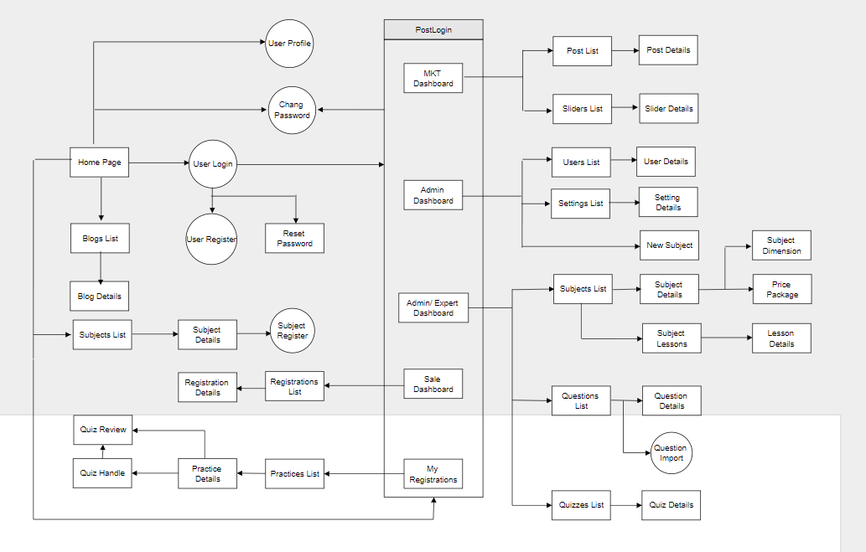

#### b. Screen Details

*[Provide the descriptions for the screens in the Screens Flow above]*

|  |  |  |  |  |
| --- | --- | --- | --- | --- |
| **#** | **Feature** | **Role** | **Screen** | **Description** |
| 1 | User Login | User | Common | This is a pop-up screen which allows the user to enter email & password to login; on this page, there are also options for user to register new information or reset the password for the case s/he forget it |
| 2 | User Register | User | Common | This is a pop-up screen which allows the user to register himself/herself to the system by inputting following information: full name, gender, email, mobile; User then need to verify by clicking the link sent via email to him/her before being able to access the system |
| 3 | Reset Password | User | Common | - On clicking the link, the user is redirected to the password resetting page in which s/he input new password (twice) for the system access  - Note that the link is only available for a specific time duration as configured in the system config file. |
| 4 | User Authorization | User | Common | Implementation of authorization mechanism in the system, including the specify the role of logged-in user, his/her authorized page links (building the displayed menu items (in the front end) and preventing unauthorized access via enter the links directly) |
| 5 | User Profile | User | Common | This is a pop-up screen which allows the user to edit his/her profile information, including the registered ones & the avatar image. Please note that s/he is not allowed to change the email |
| 6 | Change Password | User | Common | This is a pop-up screen which allows the user to change his/her password by inputting his current password as well as new password (twice) |
| 7 | Home | All | Public | - Shown slider information includes its image and title; the user is redirected to the slider's backlink on his/her clicking  - Shown post information includes its thumbnail, title, post date; the user is redirected to the post's details on his/her clicking  - Shown subject information includes its thumbnail, title, tag line; the user is redirected to the subject's details on his/her clicking |
| 8 | Blogs List | All | Public | Show the posts paginatedly (sorted by updated date) + the cider with the post search box, posts categories, latest posts, static contacts/links; Shown post information |
| 9 | Blog Details | All | Public | - Shown subject information includes its thumbnail, title, tag line, lowest price package option (list price, sale price);  - The user is redirected to the subject's details on his/her clicking on the subject  - The user can choose to register to the subject by clicking the Register button |
| 10 | Subjects List | All | Public | Show the subjects paginatedly (sorted by updated date, paginated) + the sider with the subject search box, subject categories, featured subjects, and static contacts/links;  - Shown subject information includes its thumbnail, title, tag line, lowest price package option (list price, sale price);  - The user is redirected to the subject's details on his/her clicking on the subject  - The user can choose to register to the subject by clicking the Register button |
| 11 | Subject Details | All | Public | Show subject details (including title, tag line, brief info, lowest price package option (original price, sale price), product description, and a Register button) + the sider with the subject search box, subject categories, featured subjects, static contacts/links |
| 12 | Subject Register | Customer | Public | This is a pop-up screen which allows the user to register for access to a subject. On this screen, the user needs to choose appropriate subject price package & input his/her information (full name, email, mobile, gender); A logged in user doesn't have to input those contact information |
| 13 | My Registrations | Customer | Customer | This is a pop-up screen which allows the user to register for access to a subject. On this screen, the user needs to choose appropriate subject price package & input his/her information (full name, email, mobile, gender); A logged in user doesn't have to input those contact information |
| 14 | Practices List | Customer | Customer | This page allows the user to view the list of quiz practices that s/he has taken |
| 15 | Practice Details | Customer | Customer | This page allows the user to input new practice information for practicing or to view his/her existing one |
| 16 | Simulation Exams | Customer | Customer | This page allows the user to view the existing exams of the subject that s/he has access.  • List columns: id, subject, simulation exam, level, #question, duration, and pass rate  • The user can filter the list by the subject + search list items by the exam name  From the list, the user can choose to take the exam to see the exam details, and then to go to the Quiz Handle page to practice that relevant simulation exam. |
| 17 | Quiz Handle | Customer | Learning | This screen allows the user to browse and answer the quiz questions |
| 18 | Quiz Review | Customer | Learning | This screen allows the user to review the details of the quiz that s/he has just taken |
| 19 | Dashboard | All | Marketing | Show statistics of new subjects (new, all), new registrations (success, cancelled, submitted), revenues (total, by subject categories), customers (newly registered, newly bought), and the trend of order counts (success, all) by day for the last 7 days (the start date & end date can be adjustable) |
| 20 | Post Details | All | Marketing | Show detailed post information (thumbnail, category, title, brief information, description, flag to turn the featurning on/off, status), from that allow the user to input, view or edit them |
| 21 | Sliders List | All | Marketing | Show the paginated list of sliders (including sliders' id, title, image, backlink, status) |
| 22 | Slider Details | All | Marketing | Show detailed slider information (image, title, backlink, status, notes) |
| 23 | Subjects List | All | Course Content | Show the list of course paginatedly. The shown information for each subject include the id, name, category, number of lessons, owner, and status  The user can:  - Filter the list by course category & status  - Search the course by the name  - Choose to add new course (redirect the user to the New Subject page for that)  - Edit course information (linked to the Subject Details for that) |
| 24 | New Subject | All | Course Content | The screen is shown with below information for the user to input new course information: name, thumbnail image, category, featured flag, owner, status, and description |
| 25 | Subject Details | All | Course Content | This page allows the admin and the assigned expert to access and prepare the subject information, including the course general information, the dimension, and price package. Only the admin can change the status to Published or Unpublished + add/edit the price packages |
| 26 | Subject Dimension | All | Course Content | This page allow the admin/expert to input or edit subject dimension information, including the following detailed information: type, name, description |
| 27 | Price Package | All | Course Content | This page allows the admin to input or edit subject dimension information, including the following detailed information: name, access duration (in months), status (read-only), list price, sale price, description. The expert can only view the information. |
| 28 | Subject Lessons | All | Course Content | This page shows the list of lessons for a selected package. On this page, the admin/expert is allowed to activate/deactivate, or call the Lesson Details for adding new or editing existing lesson |
| 29 | Lesson Details | All | Course Content | This page allows the admin/expert to input/edit the lesson information |
| 30 | Questions List | Customer | Test Content | The existing questions list for a specific subject/course are shown here (paginatedly). On this screen, the admin/expert is allowed to filter the questions by the subject, lesson, dimension(s), level, status + search the questions by content  Below information is shown for each question in the list: id, content, subject /dimension /lesson, level, status + options to show, hide, edit it; The page also allows the user to import the question (redirect him/her to the Questions Import pop-up screen. |
| 31 | Question Details | Customer | Test Content | This page allows the admin/expert to input or edit questions information, including following information: subject, dimension(s), lesson, status, content, media (image, audio, video – with preview option), answer options (with the key marked + ability to add, edit, delete), and explanation |
| 32 | Question Import | Customer | Test Content | This is a pop-up screen which allows the user to choose the import file and then import the questions in the file into the questions bank. The screen also provides the option for the user to download the sample import template. |
| 33 | Quizzes List | Customer | Test Content | The existing quizzes are shown in this page paginatedly:  - The user can filter the list by subject, quiz types + search quizzes by the name  - Each quiz includes following information: id, name, subject, level, # question, duration, pass rate, and the quiz type.  From this page, the user has the option to call to the Quiz Details page for adding new or editing existing quizzes + delete the quiz. Please note that the quiz can be edited only when there is not any test taken yet. |
| 34 | Quiz Details | Customer | Test Content | This page allows the user to input or edit quiz information |
| 35 | Registrations List | Customer | Sale | Show the list of users' registrations  - Each registration includes below information: id, email, registration time, subject, package, total cost, status, valid from, valid to, last updated by;  - The user can filter the list by subject (searchable), registration time (from, to), status + can search by the email  - The list can be sorted by id, email, registration time, subject, package, total cost, status, valid from, valid to  - From the list, the user can choose to add new or edit an existing registration via the Registration Details screen as below |
| 36 | Registration Details | Customer | Sale | Show detailed registration information (subject, package with list price/sale price, full name, gender, email, mobile), registration time, sale, status, valid from, valid to, notes) from that for the user to add new or change the status of a registration with relevant notes (if a registration is created by the user, then s/he can edit other registration information). On changing a registration status to Paid, if the user with relevant registered email does not exist, the system would create one and send back to the user the login information (link, email, pass) along with the other notification notes |
| 37 | Users List | Admin | Admin | Show the paginated list of registered users (include users' id, full name, gender, email, mobile, role, status):  - The admin can filter the users by gender, role, status  - Allow the admin to search users by full name, email, mobile  - The list is sortable by id, fullname, gender, email, mobile, role, status  - From each user, the admin can choose to view or edit it  - The page also have the button/link that allows the admin to add new user |
| 38 | User Details | Admin | Admin | Show detailed user information (avatar, full name, gender, email, mobile, role, address, status), from that allow the user to add new, view or edit user information  - After adding, new generated login password would be email to the new user  - The admin can only edit/update the role and status of the user |
| 39 | Settings List | Admin | Admin | Show the paginated list of settings (include settings' id, type, value, order, status):  - The admin can filter the setting by type, status  - Allow the admin to search settings by value  - The list is sortable by id, type, value, order, status  - From each setting, the admin can choose to view, activate/deactivate, or edit it  - The page also have the button/link that allows the admin to add new setting |
| 40 | Setting Details | Admin | Admin | Show detailed user information (type, value, order, description, status), from that allow the user to add new, view or edit setting information |

#### c. User Authorization

|  |  |  |  |  |
| --- | --- | --- | --- | --- |
| **Screen** | **Visitor** | **User** | **Admin** | **Teacher** |
| <<Home>> |  |  |  |  |
| View Blogs Information | x | x | x | x |
| View Post Information | x | x | x | x |
| View Subject Information | x | x | x | x |
| Find user basic information | x | x |  | x |
| <<User Profile>> |  |  |  |  |
| View Information |  | x |  | x |
| View Subject Registration |  | x | x | x |
| Able To Edit Profile |  | x |  | x |
| View Posts/Blogs Information |  | x | x | x |
| View Taken Quizzes/Exam |  | x | x |  |
| Remove Account |  | x | x | x |
| Remove Registrations |  | x | x | x |
| <<Subject>> |  |  |  |  |
| Enroll To New subject |  |  |  | x |
| Create New Subject |  |  |  | x |
| View Subject Information |  | x | x | x |
| Invited to Subject |  | x |  | x |
| Edit Subject |  |  |  | x |
| Remove Subject |  |  | x | x |
| Find subject by name/teacher | x | x | x | x |
| Sort subject by number of views/student/star/... | x | x | x | x |
| Share subject | x | x |  |  |
| <<Quizz> |  |  |  |  |
| Create new Quizz |  |  |  | x |
| remove Quiz |  |  |  | x |
| Quiz review |  | x |  | x |
| Question List |  | x |  | x |
| Question detail |  | x |  | x |
| Question import |  |  |  | x |
| Registrations List |  |  | x | x |
| Registrations Detail |  |  | x | x |
| <<admin>> |  |  |  |  |
| View subject list |  |  | x |  |
| View subject detail |  |  | x |  |
| Remove subject |  |  | x |  |
| User List |  |  | x |  |
| User Detail |  |  | x |  |
| Remove user |  |  | x |  |
| Settings List |  |  | x |  |
| Setting Details |  |  | x |  |

In which:

* Visitor: Who have not registered to the system
* User: Who have registered to the system as a student role
* Teacher: Who have registered to the system as a teacher role

Admin: Acknowledged as a head of the whole system

#### d. Non-Screen Functions

*[Provide the descriptions for the non-screen system functions, i.e batch/cron job, service, API, etc.]*

|  |  |  |  |
| --- | --- | --- | --- |
| **#** | **Feature** | **System Function** | **Description** |
| 1 | Authorization | Common | determines whether the authenticated user has access to specific resources. It verifies your permissions to grant you access to resources such as information, databases |
| 2 | … |  |  |

## 3. Common Requirements

*<<fill here with all the common requirements...>>*

# II. Functional Requirements

## 1. Common Feature

1. User Login

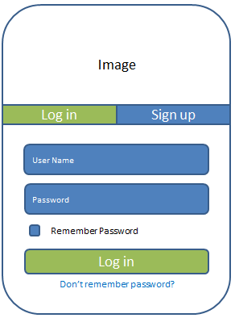

Function:

* This is a pop-up screen which allows the user to enter email & password to login.
* Users can log in automatically in the next visits to the page after clicking on the Remember Password option and Login successfully.
* Users can register new information after clicking on the Sign up button, get redirected to the sign-up pop-up.
* Users can reset the password in case s/he forgets it after clicking on “Don’t remember password?” text, get redirected to the change password pop-up.

1. User Register

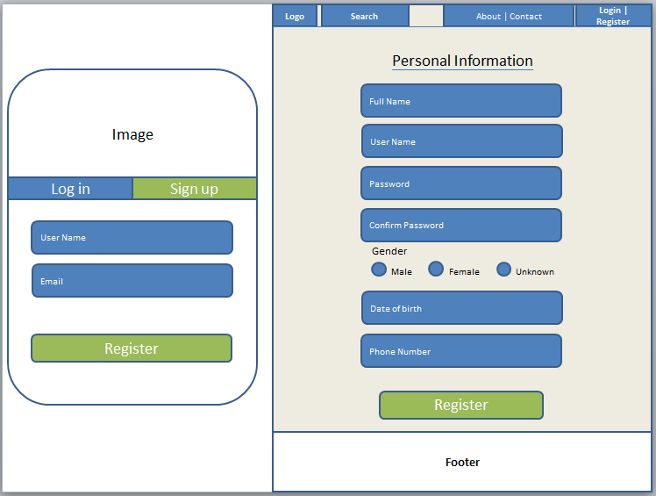

Function:

* This is a pop-up screen which allows the user to register himself/herself to the system by inputting username and email; User then need to verify by clicking the link sent via email to him/her before redirecting to the register page to inputting personal information: full name, user name (don’t change), password, gender, date of birth and phone number. After all steps, user has an account to login to the page
* User must fill correct text in the “Confirm Password” according to the password entered above to continue.

1. Reset Password

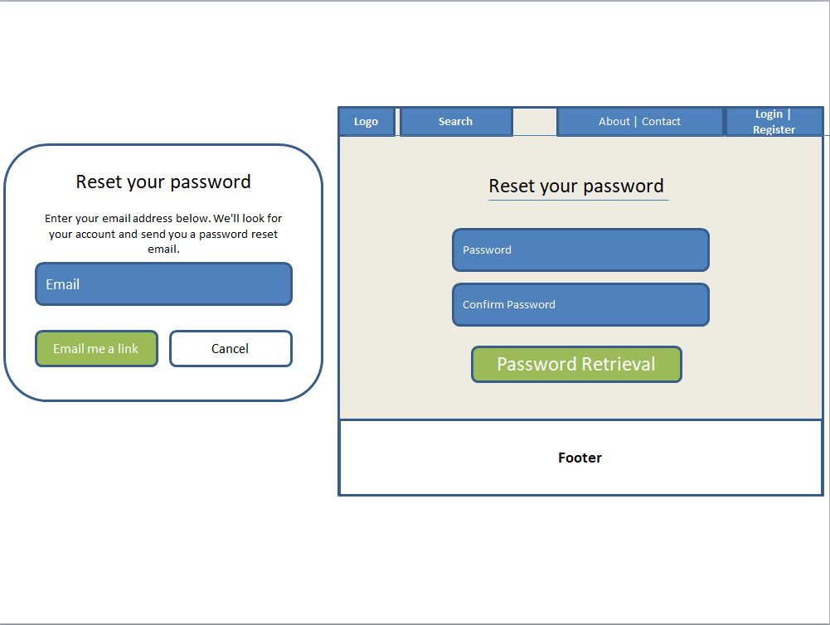

Function:

* The user input his/her email and click on the “Email me a link” button to receive the reset password link. This link is sent to the user's email for his/her password resetting.
* On clicking the link, the user is redirected to the password resetting page in which s/he input a new password (twice) for the system access.
* The link is only available for a specific time duration as configured in the system config file.

1. User Authorization (This is not actually feature)
2. User Profile

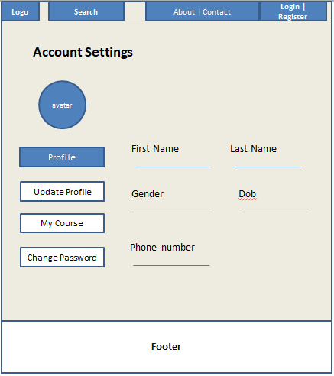

Function:

* Users can view personal information (can’t edit) in Profile tab.
* Users can change personal information in Update Profile tab.
* Users can view course registration history and get redirected to the subject’s details.

1. Change Password

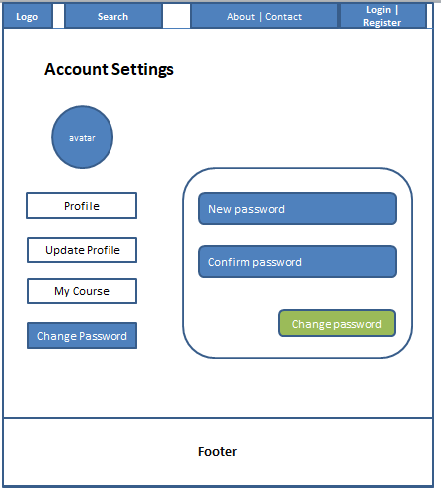

* The user input his/her email and click on the “Email me a link” button to receive the change password link. This link is sent to the user's email for his/her password resetting.
* On clicking the link, the user is redirected to the password resetting page in which s/he input a new password (twice) for the system access.
* The link is only available for a specific time duration as configured in the system config file.

## 2. Public Feature

1. Home Page

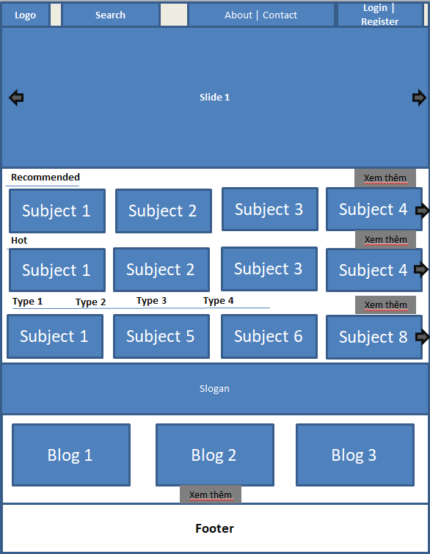

Function:

* Users can view slider information, get redirected to the slider’s backlink.
* Users can view post information, get redirected to the post’s details.
* Users can view subject information, get redirected to the subject’s details.
* Users get redirected to the page after clicking the logo on the header.
* Users can search subject when inputting in the search box
* Login | Register button can change to profile image after users login to the page, this change allows users to see personal profile, logout account.

1. Blogs List

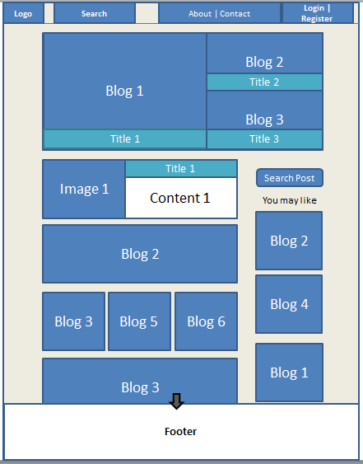

Function:

* Users can view blog information, get redirected to the blog’s details.
* Users can search blogs by blog name in the search blog box.

1. Blog Details

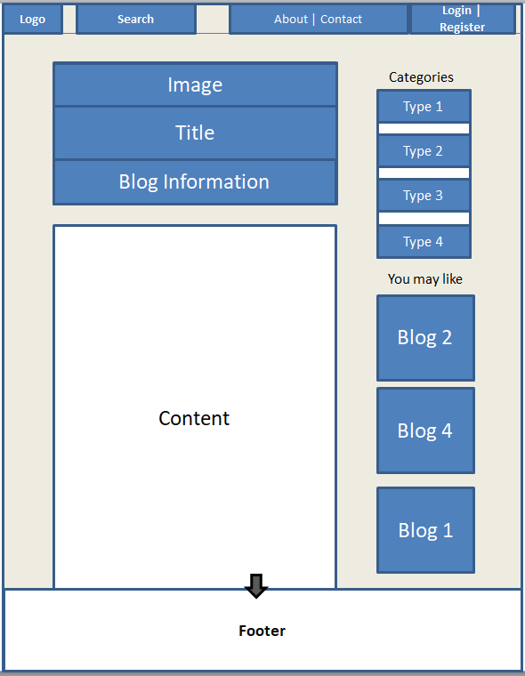

Function:

* Users can view blog information on the image.
* Users can view some type of subject in Categories List, get redirected to the subject’s list.
* Users can view blog information, get redirected to the blog’s details.
* Users can search blogs by blog name in the search blog box.

1. Subject List

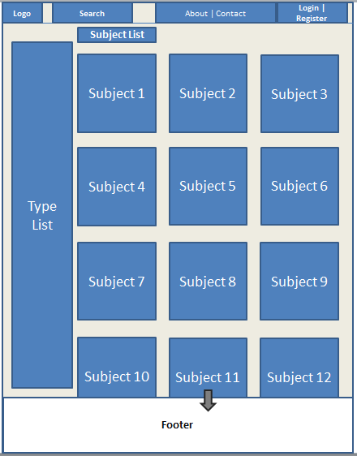

Function:

* Users can view subject information, get redirected to the subject’s details.
* Users can filter the subject by type.

1. Subject Details

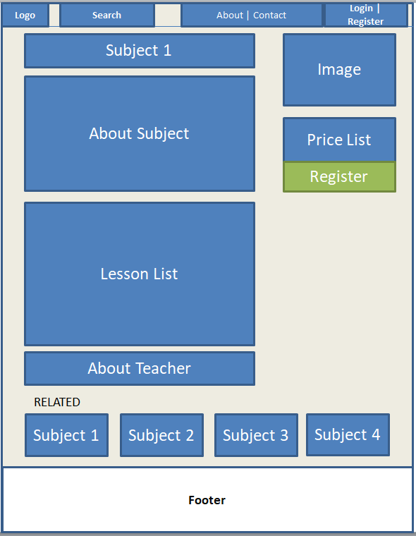

Function:

* Users can get redirected to the teacher profile’s details after clicking into teacher name or teacher image.
* Users can view subject information, get redirected to the subject’s details.
* Users can view prize package information, get redirected to the subject register page when clicking on the Register button.

1. Subject Register

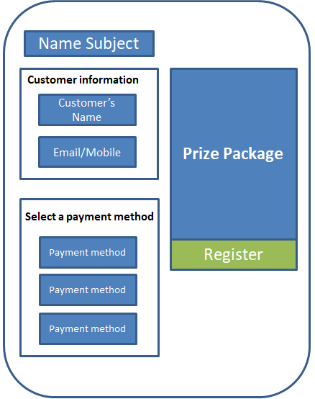

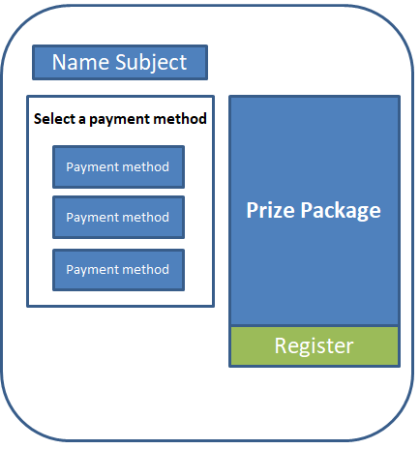

Function:

* Users can choose payment method when clicking on the payment method button
* Users can view prize package information and choose suitable prize package.
* Users can register subject after clicking into the register button.
* Customers must fill in basic personal information before registering.

## 3. Customer Feature

This includes the screens used for the system customers, as listed below

**a. My Registrations**

This page is for the customer to view his/her submitted course registrations

**b. Practices List**

This page allows the user to view the user’s list of quiz practices that s/he has taken. The

screen layout is as below, in which the user can:

- Click the New Practice button to go to the Practice Details page

- Click View Details to go to the Practice Details page

- Click Simulation Exam to get to the Simulation Exam page

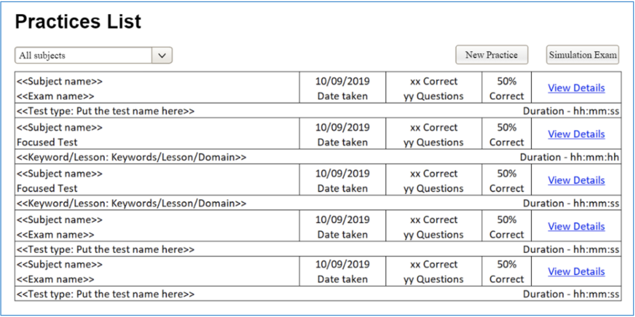

c. Practice Details  
This page allows the user to input new practice information for practicing or to view his/her  
existing one. The screen layout is as below

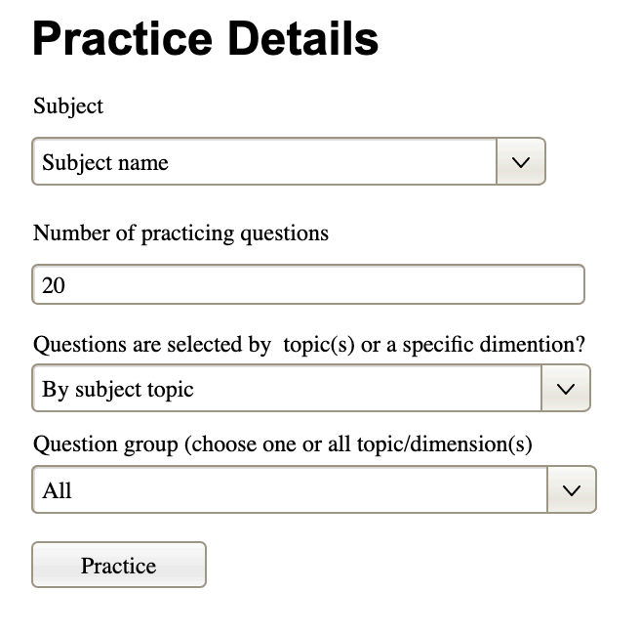

When creating new practice, the user can only choose the subjects that s/he has the access  
Click Practice button, user would be redirected to the Quiz Handle page  
In case the user has come to the page by viewing it, the information on the page is read-only,  
and the button Practice is now Practice Review, from that the user can click to go to the Quiz  
Review page

d. Simulation Exam  
This page allows the user to view the existing exams of the subject that s/he has the access.  
• List columns: id, subject, simulation exam, level, #question, duration, and pass rate  
• The user can filter the list by the subject + search list items by the exam name  
From the list, the user can choose to take the exam to see the exam details, and then to go to  
Quiz Handle page to practice that relevant simulation exam.  
e. Quiz Handle  
This screen allows the user to browse and answer the quiz questions. The screen layout is as  
below

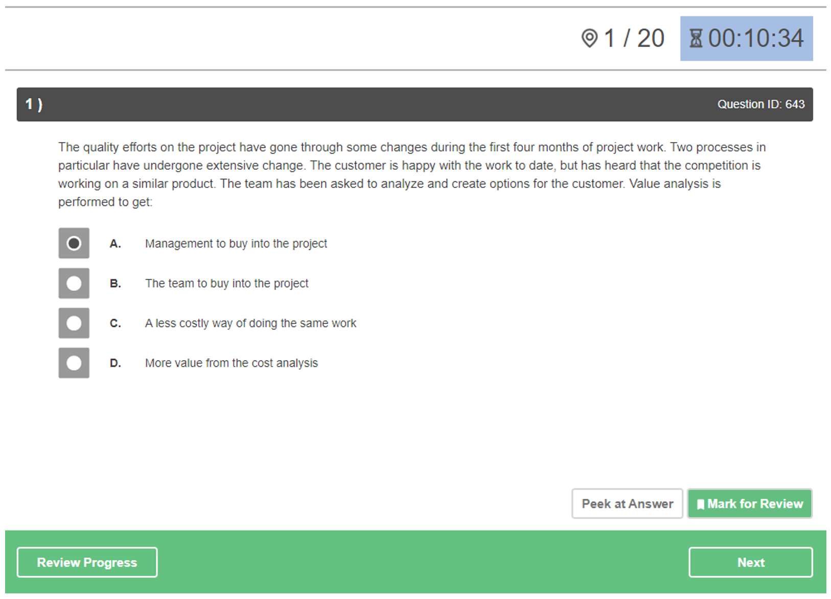

Notes about the buttons in the right side of the footer:  
• First question: have Next button only  
• Last question: have Previous & Score Exam buttons  
• Middle question: have Previous & Next buttons  
Other notes:  
• The timer is counting down for simulation exam and counting up for practicing quiz  
• The button Peek at Answer only available for the practicing quiz, not for simulation exam  
• During quiz-taking progress, if the user chooses to refresh the page, there is no impact  
The pop-up screen below would be shown if the user clicks the Peek at Answer button

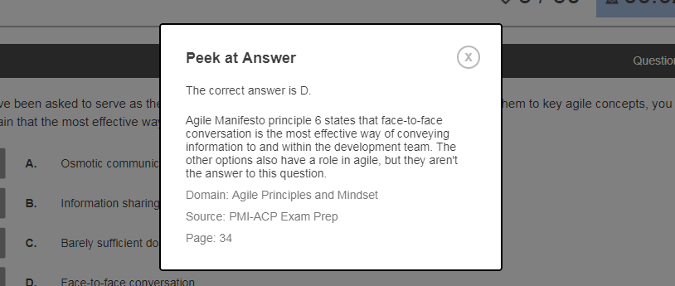

When the user clicks the Review Progress button, the below pop-up screen would be shown  
with 4 options UnAnswered, Marked, Answered, and All Questions with which, the user can  
filter relevant question numbers to show. By clicking on each question number, the user is  
redirected back to the Quiz Handle screen and at the chosen question.

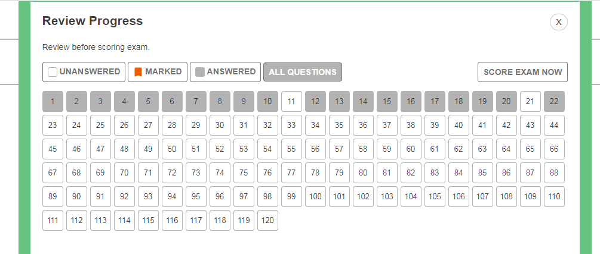

If the user chooses to Score Exam (at the last question in the Quiz Handle screen or to Score  
Exam Now in the above pop-up screen), the confirmation pop-up would be shown as below  
• If there is not any answered question answered, allow the user to continue the testing or  
coming back to the Quiz Lesson page (SubForm1 ~ Quiz Description)

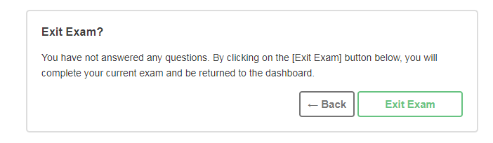

If there are some unanswered questions, allow the user to continue the testing or to quiz the  
quiz & coming to the Quiz Lesson page (SubForm2 ~ Quiz Result)

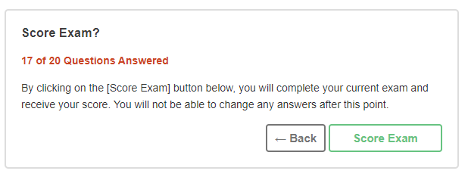

If all the questions are answered, allow the user to continue testing or to submit the testing  
and coming to the Quiz Lesson page (SubForm2 ~ Quiz Result)

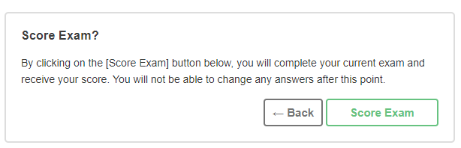

f. Quiz Review  
This screen allows the user to review the details of the quiz that s/he has just taken. The  
screen layout is as below

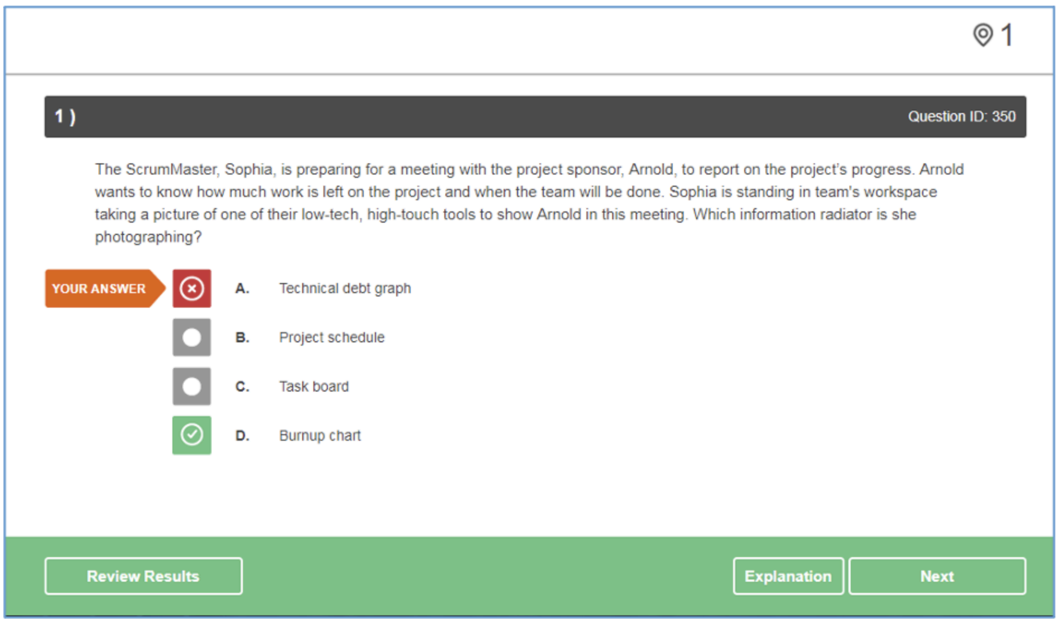

The Explanation button is available only when the question is attached with un-empty  
explanation  
When the user clicks the Review Result button, the below pop-up screen would be shown with  
4 options Marked, Answered, Incorrect, and All Questions with which, the user can filter  
relevant question numbers to show. By clicking on each question number, the user is redirected  
back to the Quiz Review screen and at the chosen question

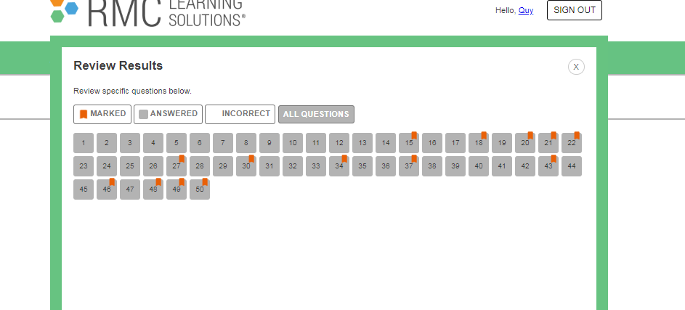

When the user clicks the Explanation button of the Question Review screen

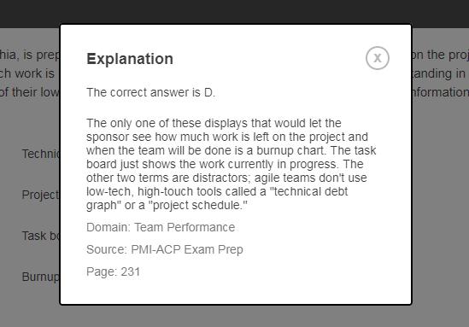

## 4. Marketing Feature

This includes the screens used for marketing members, as listed below  
- Dashboard: This is for the Admin, Sale or Marketing to see and lookup for the relevant  
management statistics in the system, with the relevant links to the related screens.  
- Posts List: list, filter, search, show, hide, view, add new or edit existing post(s)  
- Post Details: view & edit the details of a specific post  
- Sliders List: list, filter, search, show, hide, view, add new or edit existing slider(s)  
- Slider Details: view & edit the details of a specific slider

## 5. Course content

a. Subject list:

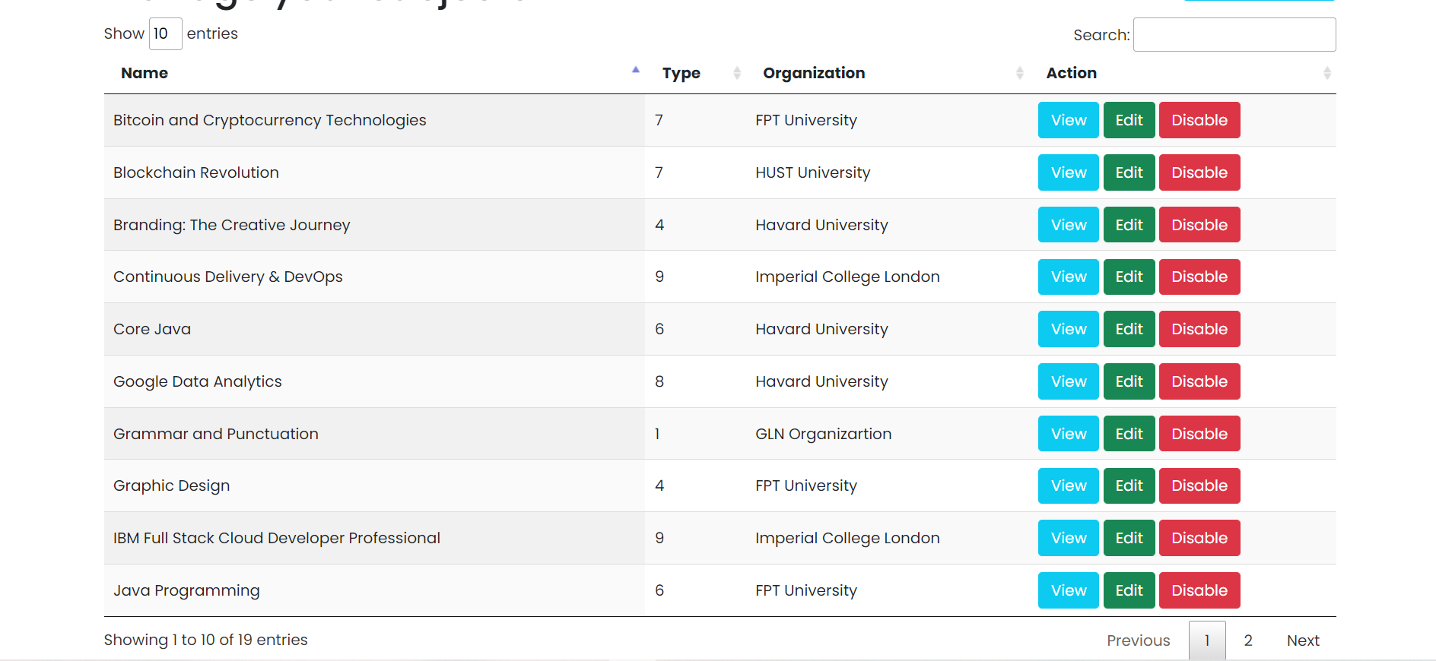

Trigger: homepage --> Manage Subjects

Description: Admin can view all courses while Expert can only view assigned courses.

Data Processing: get the list of courses from database according to user type

b. New Subject:

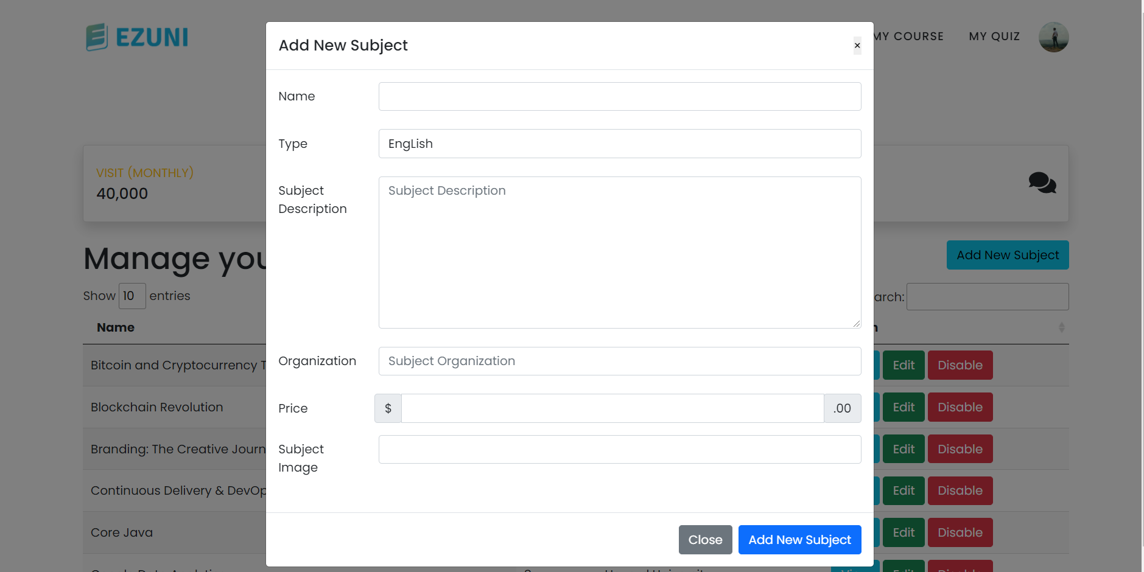

Trigger: homepage --> Manage Subjects --> Add new subject

Description: Admin can add a new subject and assign an expert to that subject.

Data processing: add a new subject to the subject table.

c. Subject Detail:

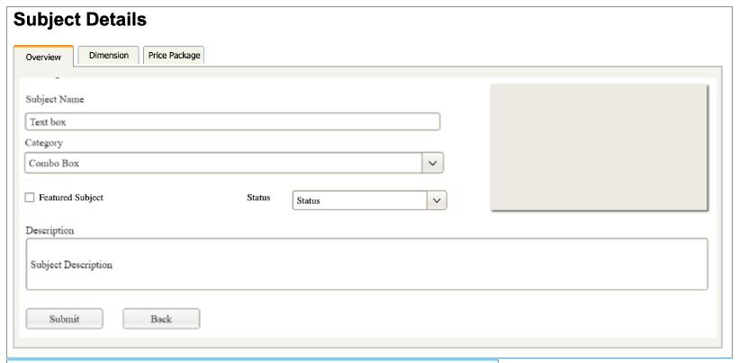

Trigger: homepage --> Manage Subjects --> Subject Detail

Description: Admin/Expert can edit course general information, dimension, price package. Admin can change the status of Published/Unpublished and change/add price package

Data processing: add/ update attribute in subject table

d. Subject Dimension:

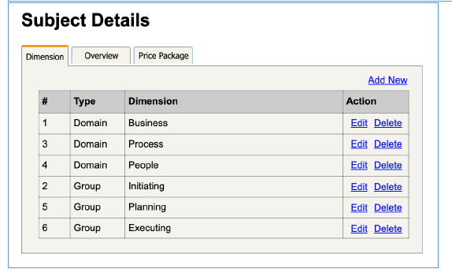

Trigger: Home --> Manage Subjects -->Subject Detail--> Dimension

Description: admin/expert to input or edit subject dimension information including: type, name, description.

Data processing: add/update information in dimension table

e. Price package:

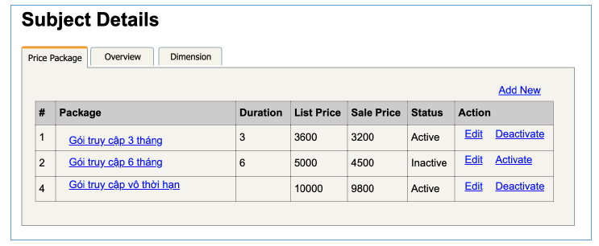

Trigger: Home --> Manage Subjects -->Subject Detail --> Price package

Description: admin can add/edit price package information including: name, access duration (in months), status (read-only), list price, sale price, description.

Data processing: add/update information in price package table

f. Subject Lessons:

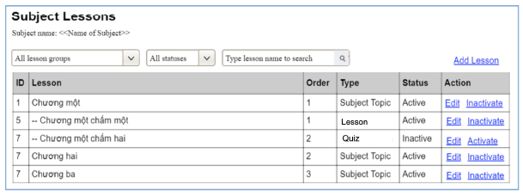

Trigger: Home --> Manage Courses

Description: admin/expert can view a list of lesson activate/deactivate.

Data processing: select information/change status from lessons table

g. Lesson Detail:

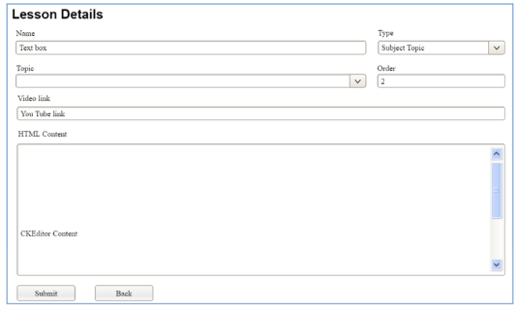

Trigger: Home --> Manage Courses --> Lesson Detail

Description: admin/expert can input/edit the lesson information.

Data processing: add/edit information from lessons database

## 6. Testing Content

a. Question List:

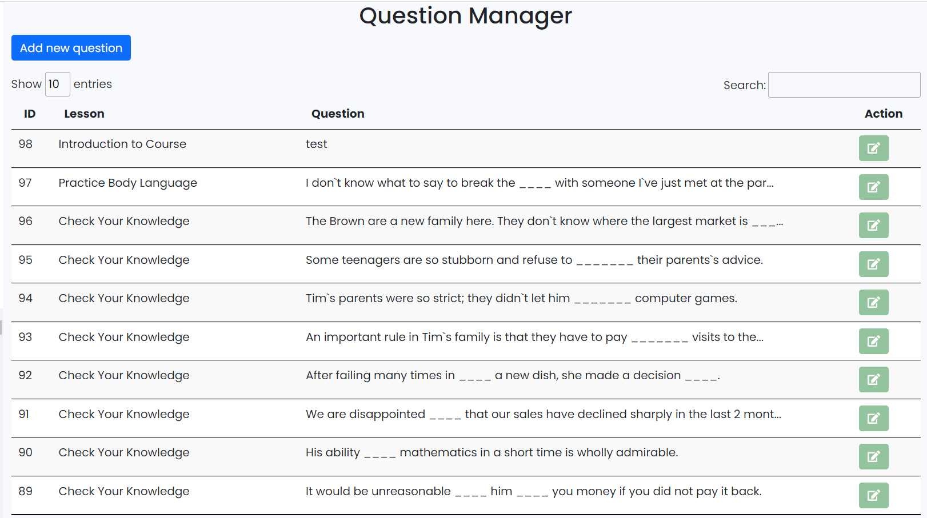

Trigger: Home -- > Manage Question

Description: admin/expert is allowed to filter the questions by the subject, lesson, dimension(s), level, status + search the questions by the content .

Data processing: read information in question table.

b. Question Details:

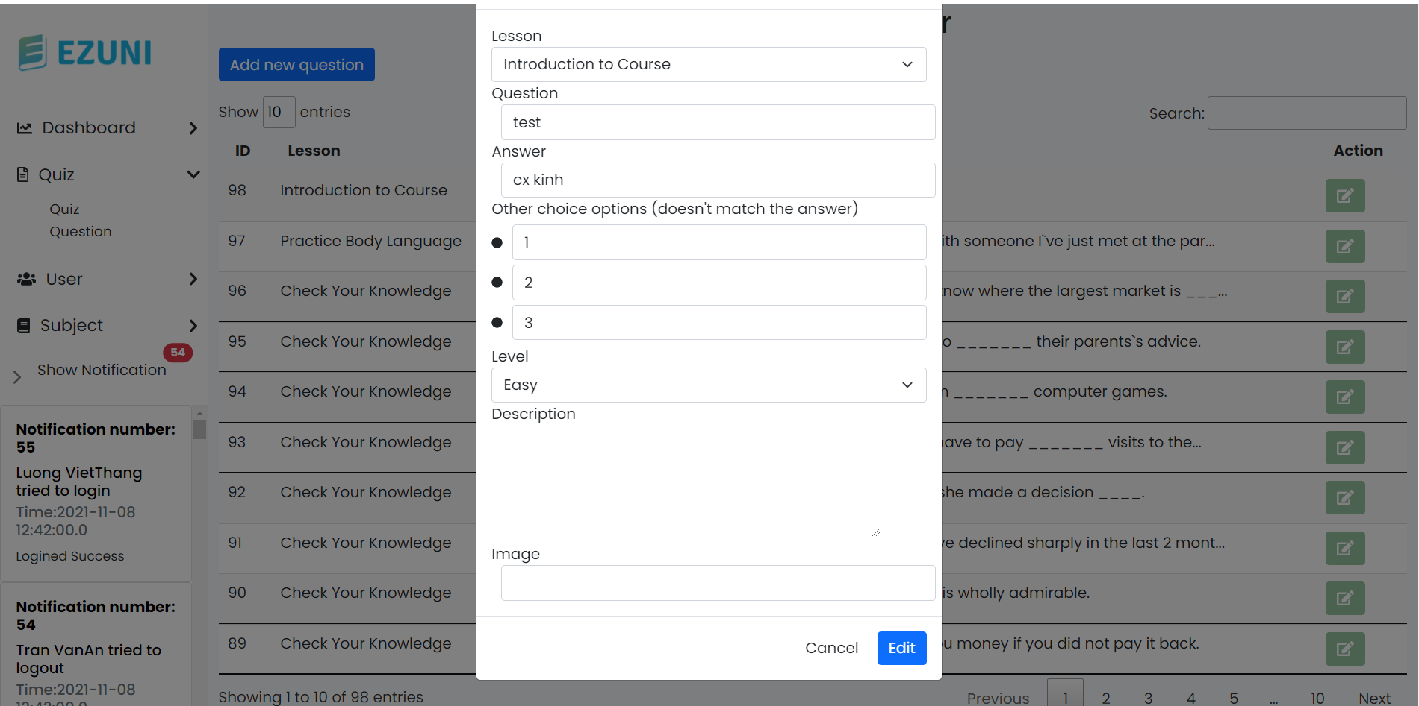

Trigger: Home -- > Manage Question --> Question Detail

Description:admin/expert can input or edit questions information:subject, dimension(s), lesson, status, content, media (image, audio, video – with preview option), answer options (with the key marked + ability to add, edit, delete), and explanation .

Data processing: add/update information in question table

c. Question Import:

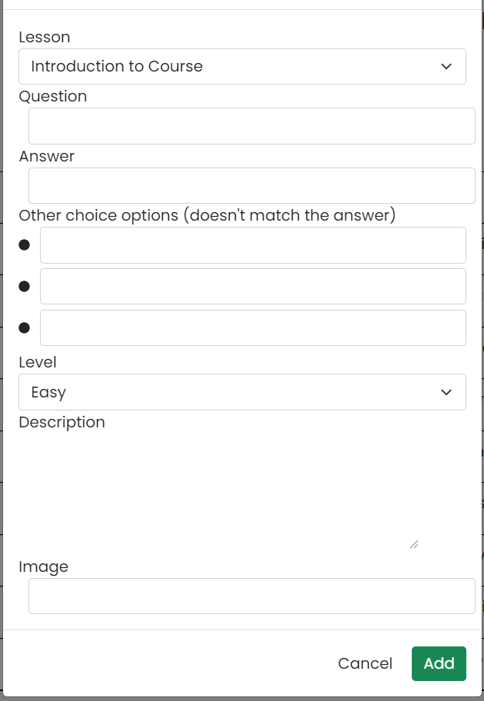

Trigger:Home -- > Manage Question --> Question Import

Description: user can import file and import the questions in the file into the questions bank or download sample import template.

Data processing: add information to question table

d. Quizzes List:

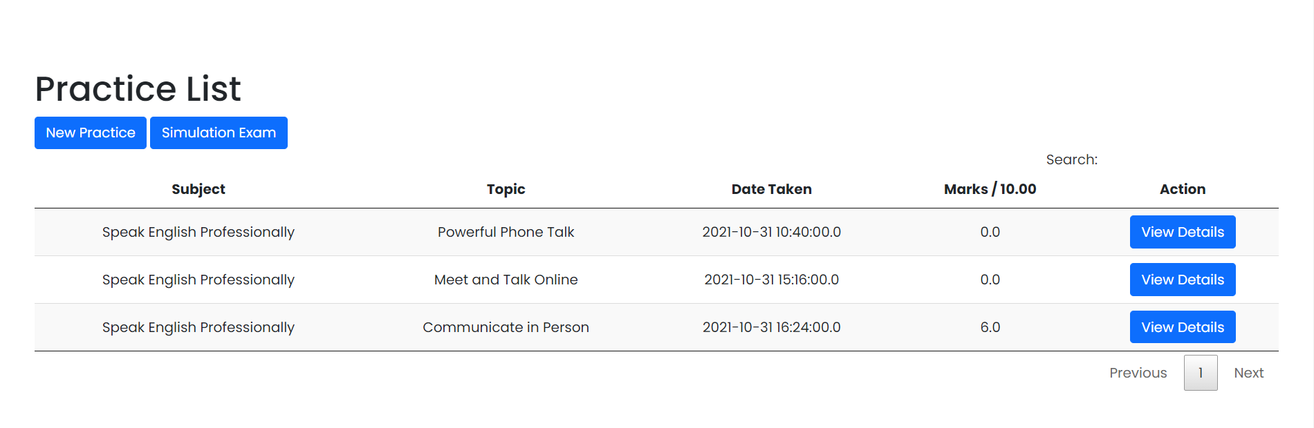

Trigger: Homepage --> Quizzes List

Description: user can view a list of quizzes, which can be filtered by subject, quiz types + search quizzes by the name.Every quiz has following information: id, name, subject, level, # question, duration, pass rate, and the quiz type.

e. Quiz detail:

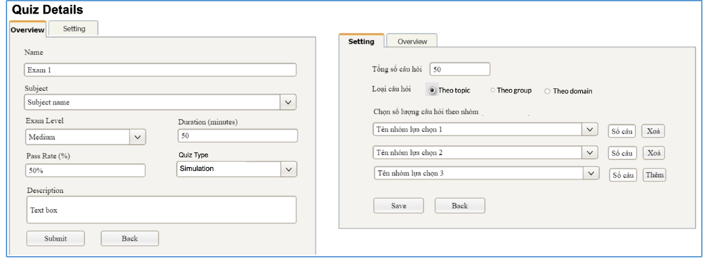

Trigger: Homepage --> Quizzes List → Quiz Detail

Description: the user can add new or edit existing quiz + delete the quiz. The quiz can be edited only when there is not any test taken yet.

## 7. Sales Feature

**This includes the screens used for sale persons**

a. Registrations List

Show the list of users' registrations

- Each registration includes below information: id, email, registration time, subject, package, total cost, status, valid from, valid to, last updated by;

- The user can filter the list by subject (searchable), registration time (from, to), status + can search by the email

- The list can be sorted by id, email, registration time, subject, package, total cost, status, valid from, valid to

- From the list, the user can choose to add new or edit an existing registration via the Registration Details screen as below

b. Registration Details

Show detailed registration information (subject, package with list price/sale price, full name, gender, email, mobile), registration time, sale, status, valid from, valid to, notes) from that for the user to add new or change the status of a registration with relevant notes (if a registration is created by the user, then s/he can edit other registration information). On changing a registration status to Paid, if the user with relevant registered email does not exist, the system would create one and send back to the user the login information (link, email, pass) along with the other notification notes

## 8. Admin Feature

The Admin feature includes the screens used for the organization manager and system administrator, as listed below

- Users List: list, filter, search, show, hide, view, add new or edit existing user(s)

- User Details: view & edit the details of a specific user

- Settings List: list, filter, search, show, hide, view, add new or edit existing system setting(s)

- Setting Details: view & edit the details of a specific system settin